**Quiz 1**

Chapter 15

**Submitted to:**

Ms. Maria Khan

**Submitted by:**

Hamza Farooq (2016-CS-122)



June, 2020

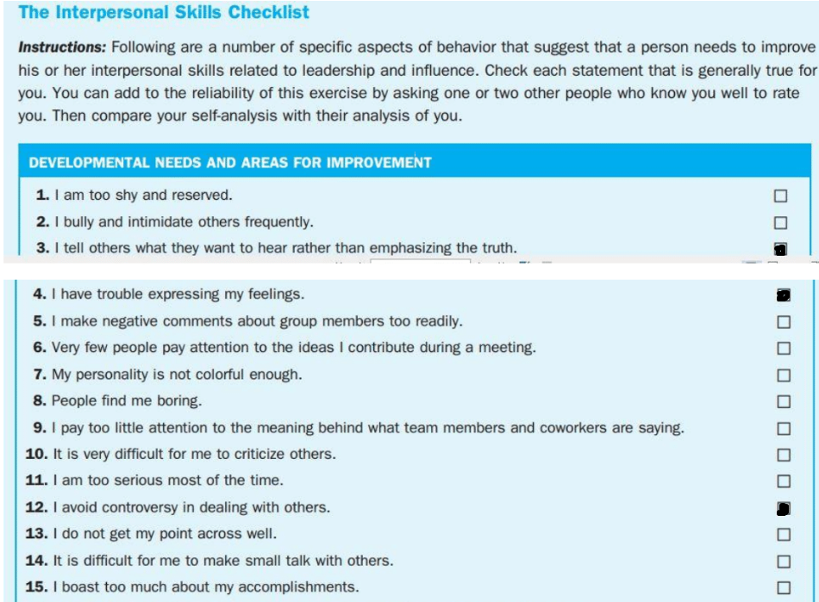

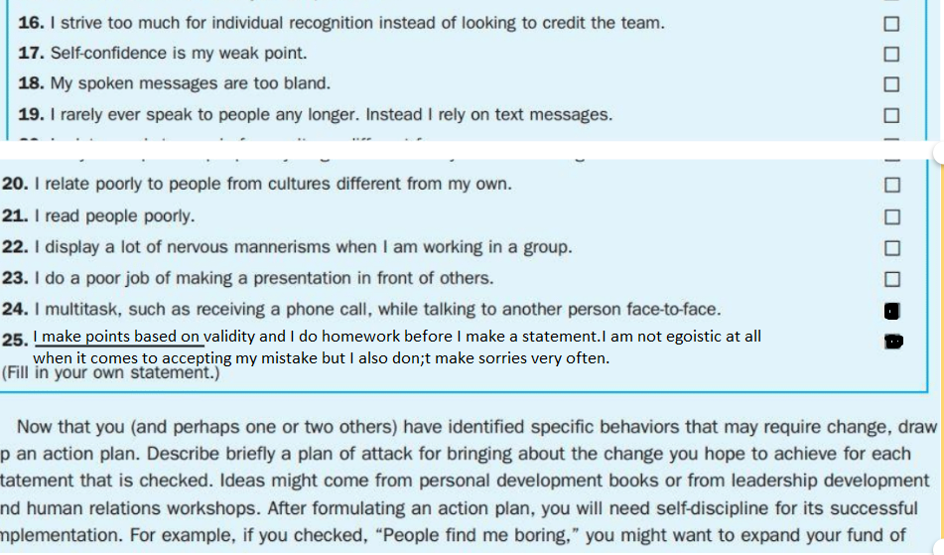

**Action Plan**

I am working on how to convince people to the truth with effective tone and gracious choice of words. Also, I am working on how to deal with controversies elegantly such that it makes no difference to my mood as well as the reputation that I have built in business.